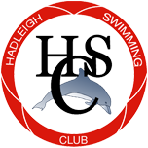
Sponsorship Packages
Contact us at HadleighSCfundraising@gmail.com
Or call Laura on 07423 188414, or Ian on 07778 880589
Hadleigh Swimming Club was formed in 1971, and welcomes swimmers interested in competing, fitness or just for fun. The club has produced county and regional finalists within the last year and is a friendly and sociable place. We are very much looking forward to moving into the new pool when it is completed in the summer of 2020, and one of our aims is to begin hosting open meets. This will enable our swimmers to enjoy the buzz of swimming in a home meet, and will allow the club to raise vital funds to ensure that swimming in Hadleigh and the surrounding area continues to flourish. In order to do this we need to raise funds to buy a timing system and scoreboard, and as such we are offering sponsorship packages to help achieve our target.
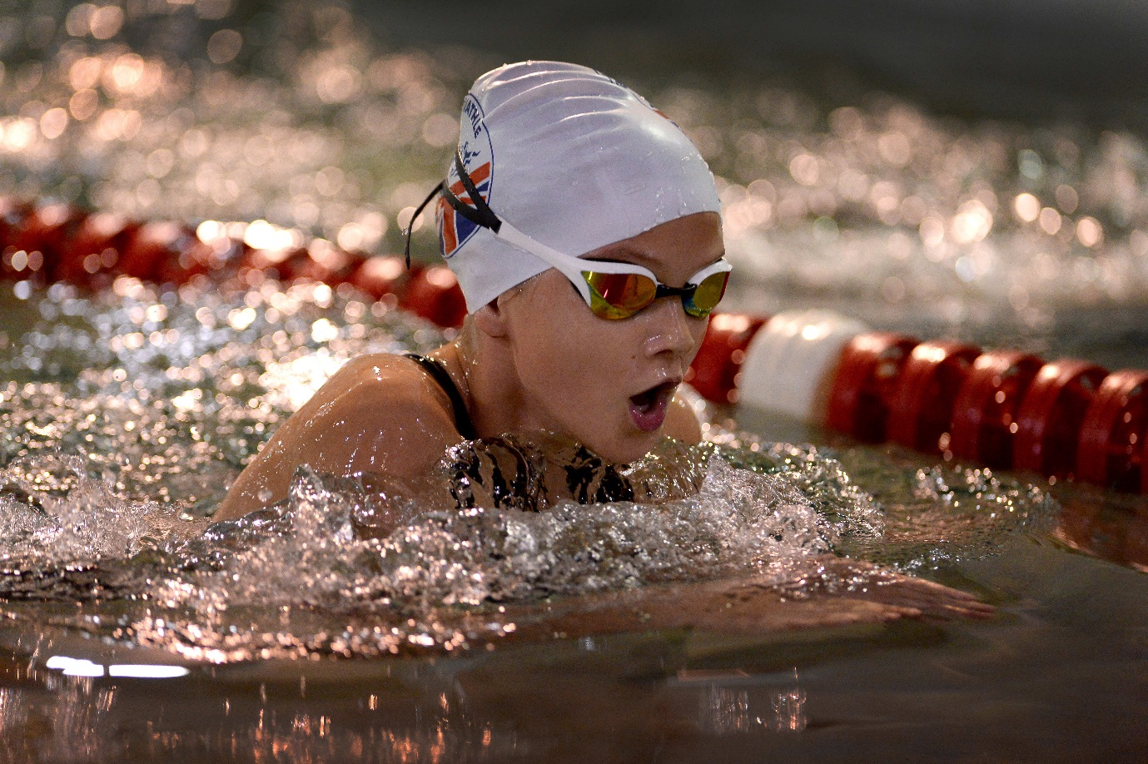
Gold Package - £2,000 per year

Gives you :

Link to your website on the club website.

3 months free membership to a child nominated by you (or 1 month free for 3 children) in
our coaching development squad.

We guarantee that we will not have a direct competitor of yours as sponsor.

We will display a banner at training, home galas and away galas (if permission granted by
host club). Banner to be provided by you.

Your logo on all club kit ordered during the year.

Full page advert in any HSC programmes (artwork to be provided by you)

If we achieve our goal in your sponsorship period, we will display your logo on our new
screen!

Please also think of us if you have raffle prizes to donate.

Terms and Conditions of sponsorship

- Sponsorship agreements are for a duration of twelve months, beginning from the date of invoice.
- Payment of the invoice is due in full within 30 days from the date of the invoice, please pay to the club account - Sort code 309455, Account Number 04237227.
- If an incident occurs which means that continuing to advertise as a sponsor you would be detrimental to the club, then the club reserve the right to discontinue our obligations without refund. Examples of such incidents would include (but not limited to) insolvency, criminal act, severe scandal.
- Any persons who would legally be defined as owners or part owners of a club sponsor are prohibited from serving on the club committee for the duration of the sponsorship in order to avoid conflicts of interest.
- This sponsorship agreement can only be ended early by mutual consent, and the club will refund a proportion of the sponsorship fee.
- The club warrants to give existing sponsors first refusal to renew sponsorship for a further 12 months before selling the spot to another organisation.
- There will be a maximum of one gold package and 5 silver packages available at any one time.

We agree these terms and conditions and wish to purchase one of these sponsorship agreements from Hadleigh Swimming club.

Signed

………………………………… Date ……………………….

